Security Threat Analysis Dashboard
Milestone 1 Report | Power BI Security Incident Analytics
1. Objective
The objective of Milestone 1 was to build the baseline incident-reporting dashboard for the Threat Classification & Severity Analytics project. Working as a Data Analyst, the task involved acquiring, cleaning, integrating, and modelling three underlying datasets so that security incidents could be classified, scored for severity, and tracked for response performance. The resulting Power BI dashboard is designed to give decision-makers a single, interactive view of how many incidents are occurring, how critical they are, how quickly they are being resolved, and where they are distributed geographically. It combines KPI cards, category and trend charts, severity and impact breakdowns, and a set of slicers (Date, State, Threat Category, and Severity) so that analysts can filter the full incident base down to any slice of interest and immediately see how the headline metrics change.
Key Performance Indicators at a Glance
TOTAL INCIDENTS  2K | CRITICAL INCIDENTS  267 | AVG. RESPONSE TIME  1.09 | THREAT SEVERITY INDEX  61.72

2. Dashboard Screenshot
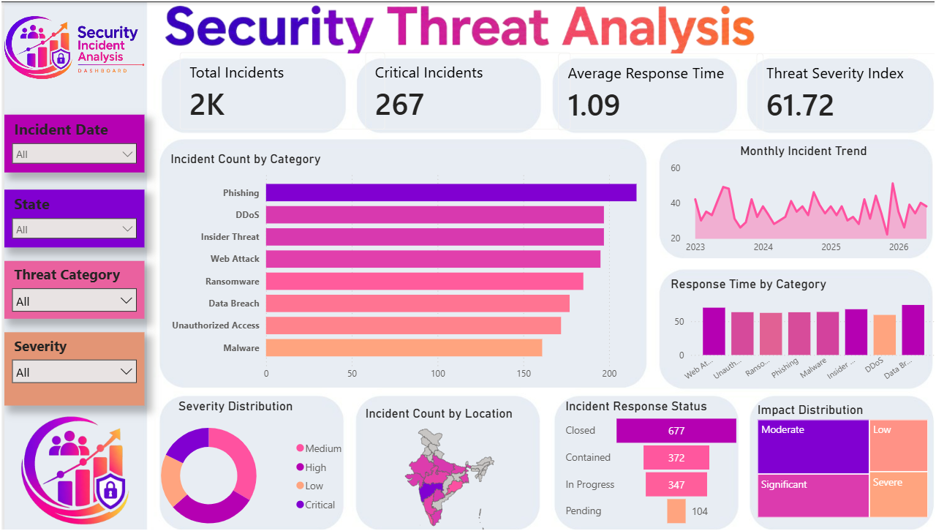
Figure 1: Security Threat Analysis Dashboard — Power BI
The dashboard is organized around four interactive slicers (Incident Date, State, Threat Category, and Severity) on the left rail, allowing analysts to filter every visual on the page at once. The top strip surfaces four headline KPIs, while the central canvas pairs an Incident Count by Category bar chart with a Monthly Incident Trend line chart spanning 2023–2026 and a Response Time by Category bar chart. The lower band adds a Severity Distribution donut, an Incident Count by Location map of India, an Incident Response Status breakdown (Closed, Contained, In Progress, Pending), and an Impact Distribution panel covering Moderate, Significant, Low, and Severe outcomes.

3. Three Key Insights
- Insight 1 — Threat exposure is broad-based rather than concentrated in one vector. The Incident Count by Category chart shows Phishing as the leading category, but DDoS, Insider Threat, Web Attack, Ransomware, Data Breach, Unauthorized Access, and Malware all fall within a similarly close range just behind it. This tight clustering indicates the organization faces a diversified attack surface, so a defense strategy built around any single threat type would leave most of the incident volume unaddressed.
- Insight 2 — A meaningful share of incidents remain unresolved at any given time. The Incident Response Status panel shows 677 incidents Closed against 372 Contained, 347 In Progress, and 104 Pending. Together, the Contained, In Progress, and Pending categories represent an ongoing caseload roughly comparable in size to everything already closed, which — combined with 267 Critical Incidents and a Threat Severity Index of 61.72 — points to a working backlog that response teams need sustained capacity to keep from growing.
- Insight 3 — Risk is concentrated in the middle severity tiers and recurs cyclically rather than as one-off spikes. The Severity Distribution and Impact Distribution views show Medium/High severity and Moderate/Significant impact accounting for the bulk of incidents, with Critical and Severe present but smaller in share. The Monthly Incident Trend line oscillates repeatedly between roughly 20 and 60 incidents across 2023–2026 without a sustained upward or downward trend, suggesting the organization is dealing with a persistent, recurring incident pattern rather than isolated events.
4. Two Business Recommendations
1. Invest in category-agnostic detection and response capability rather than single-vector defenses. Because Phishing, DDoS, Insider Threat, Web Attack, Ransomware, Data Breach, Unauthorized Access, and Malware all cluster closely in incident volume, hardening defenses against only the top category would leave the organization exposed on most fronts. Security investment should prioritize shared detection tooling and response playbooks that scale across categories, supplemented by category-specific controls only where the Response Time by Category view shows the slowest handling.
2. Target the Contained, In Progress, and Pending backlog to reduce the pool of incidents that can escalate to Critical. With 372 Contained, 347 In Progress, and 104 Pending incidents outstanding alongside 267 already Critical, allocating additional triage staff toward closing this backlog — starting with the oldest Pending cases — would lower the Threat Severity Index over time and reduce the average response time of 1.09, before incidents have a chance to escalate further.

